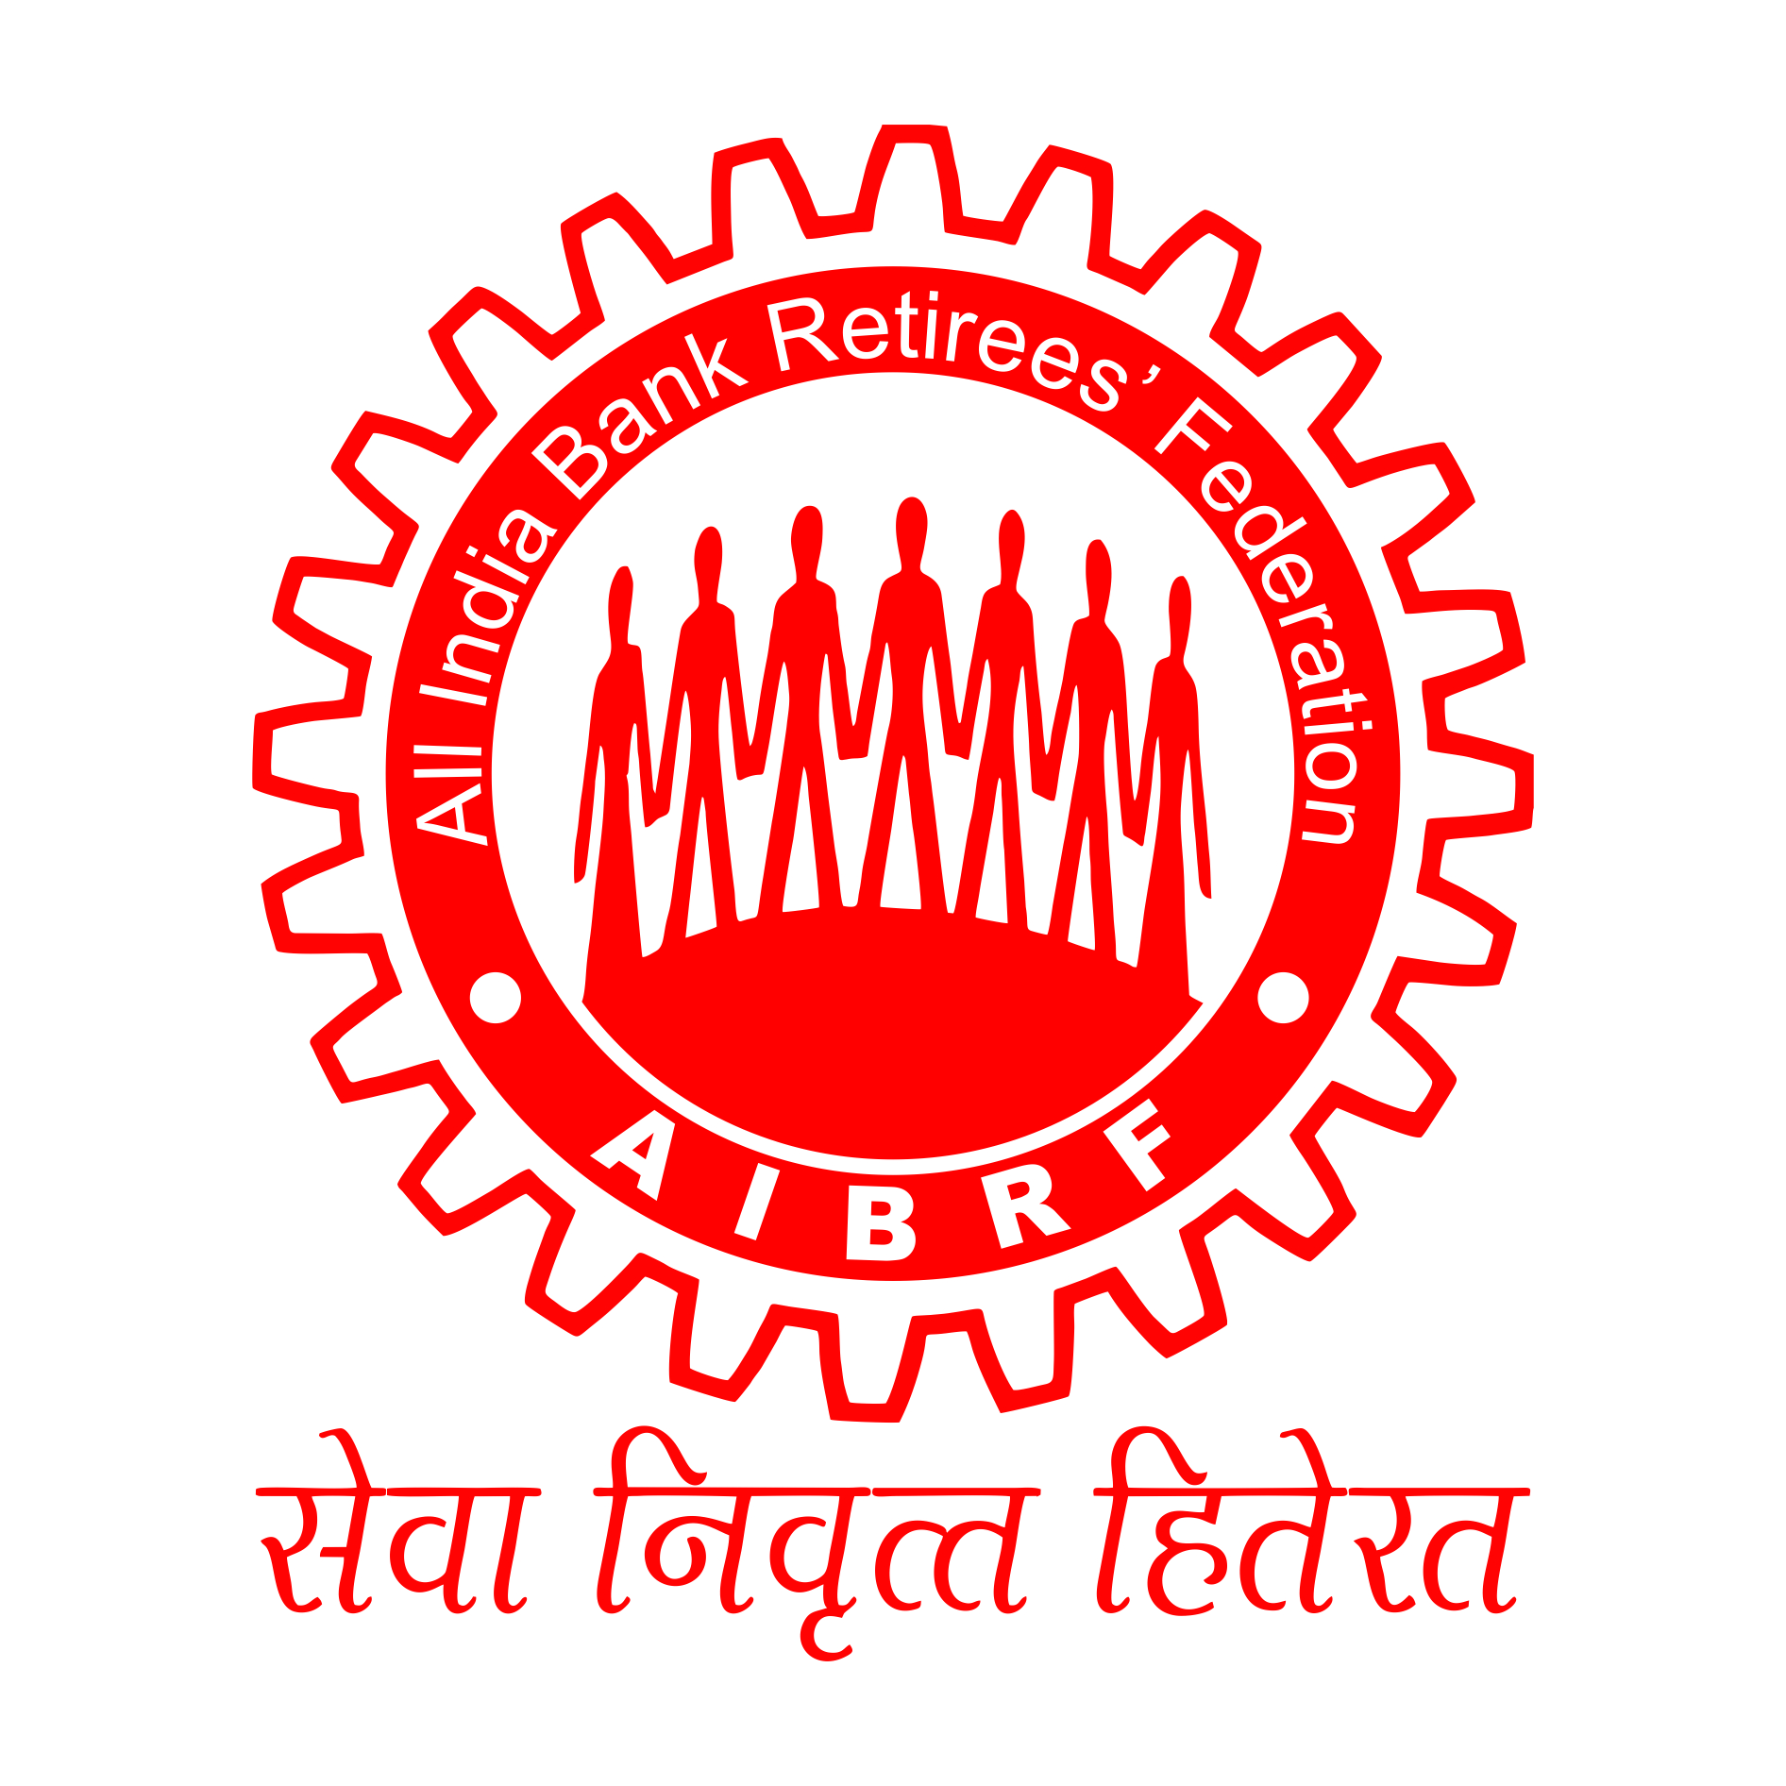
ALL INDIA BANK RETIREES’ FEDERATION(Regd)
(Regd No:G:6601 under the trade union act)
D-101, Sector-C, Scheme 71, Near Kasara Bazar, Indore-452009

Ref: 2016/554 Date: 10.10.2016

OBs/ C. C.Ms/ State Body Chiefs,A.I.B.R.F

Dear Comrades,

Re: Renewal Premium for Group Medical Insurance for Retirees.

We understand that today United India Insurance Company Ltd has finalised amount of renewal premium to be charged to the retirees for the year 2016-2017.

2. While finalising the renewal premium we find that the insurance company has introduced one more option of insurance coverage for the retirees. Option No I is renewal without provision of reimbursement of domiciliary expenses and Option No. II is renewal covering risk for reimbursement of domiciliary expenses for 59 identified deceases with ceiling of 10 percent of sum assured within overall limits. Details are as under:

Option I: Normal Renewal onAs Is Basis (Without Domiciliary cover)
For Retired Officers (Sum Insured of Rs. 4,00,000) : Rs. 13,935Plus Service Tax @15% = Rs. 16,025/-
For Retired Award Staff (Sum Insured of Rs. 3,00,000) : Rs. 10,452 Plus Service Tax @15% =Rs. 12,020/-

Option II: With Domiciliary Expenses Benefits Option (59 diseases as per Employees Policy):
For Retired Officers -Domiciliary Cover of Rs. 40,000 with overall Sum Insured of Rs.4,00,000.
For Retired Award staff -Domiciliary Cover of Rs. 30,000 with overall Sum Insured of Rs.3,00,000.
For Retired Officers : Rs. 17,400 Plus Service Tax @15% = Rs.20,010/-
For Retired Award Staff : Rs. 13,000 Plus Service Tax @15% = Rs.14,950/-
2. Though the premium fixed is not as per our expectation, we find that insurance company has taken some steps to resolve long pending issue of domiciliary expenses which may give required additional risk coverage to the membership and come as required financial support in day to day health management at the advancing age. Though the premium is on higher side because of claim ratio of 230 percent in the first year and we request you to take it as pinch of salt and renew the policy so this group medical scheme get stabilized on long term basis and the organisation can take steps in future to make it affordable and reliable insurance scheme.
3. We find that some retiree organisations were circulating the information that renewal premium will be at the same level as last year. We do not know what was the source of information for them in circulating this news, our request to the membership is not to believe on unwarranted rumors and only trust on the information given by AIBRF.
4. We request our affiliates to be in touch with the bank managements at the respective banks to ensure smooth renewal by the maximum memberships.

With Warm Greetings,

Yours Sincerely,

( S.C.JAIN )
GENERAL SECRETARY
______________________________________________________________REPRODUCED BY VIJAYA BANK RETIREES’ ASSOCIATION(Regd)- FOR INFORMATION OF ALL BANK RETIREES .

(K.Vishwanath Naik)
General secretary
VIJAYA BANK RETIREES’ ASSOCIATION(Regd)

K.VISHWANATH NAIK
General Secretary-VBRA.

